**Waterfall Model**

**Description**

The Waterfall Model is a straight successive stream. In which progress is viewed as streaming relentlessly downwards (like a cascade) through the periods of programming usage. This implies any stage in the improvement procedure starts just if the past stage is finished. The cascade approach doesn't characterize the procedure to return to the past stage to deal with changes in necessity. The cascade approach is the soonest approach and most broadly realized that was utilized for programming improvement.

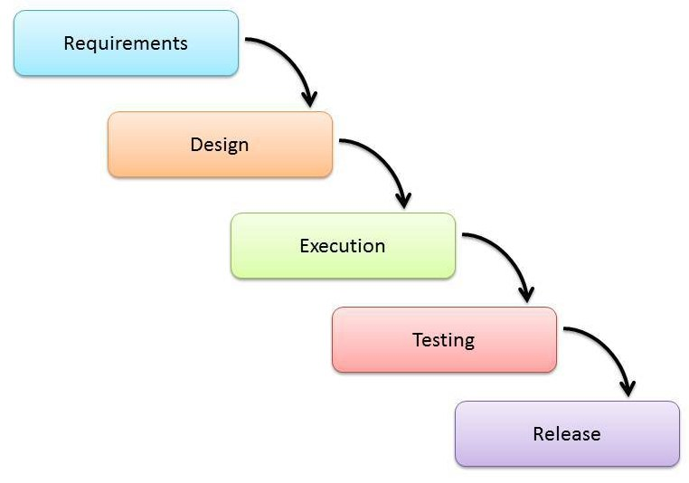

projects which not concentrate on changing the necessities, for instance, projects or ventures started from a solicitation for proposition , the client has an exceptionally clear reported prerequisites

**Advantages:**

* Easy to explain to the users.
* Structures approach.
* Activities and stages are well defined.
* Each phase has specific deliverables.
* Helps to plan and schedule the project.
* Confirmation at each stage guarantees early location of errors/misconception.

**Disadvantages:**

* Assumes that the prerequisites of a framework can be solidified.
* Very hard to return to any phase after it wrapped up.
* A little adaptability and modifying degree is troublesome and costly.
* Costly and required more time, in addition to the detailed plan.

**Agile Model**

**Description**

It depends on iterative and incremental development model, where prerequisites and arrangements develop through joint effort between cross-utilitarian groups Agile development model is additionally a sort of Incremental model. Programming is created in incremental, fast cycles. This outcome in incremental discharges with each discharge expanding on past usefulness. Each discharge is completely tried to guarantee programming quality is kept up. It is utilized for time basic applications. Extraordinary Programming (XP) is as of now one of the most outstanding nimble agile developing life cycle model.

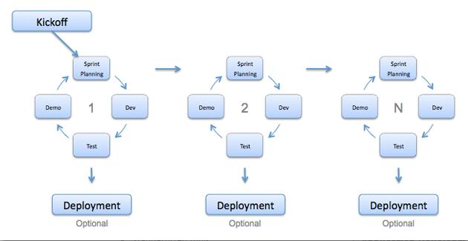

**Advantages:**

* Decrease the time needed to avail some system features.
* Peer to peer communication and continuous inputs from customer representative leaves no space for guesswork.

**Disadvantages:**

* Scalability.
* The ability and collaboration of the customer to express user requirements.
* Documentation is done at later stages.
* Reduce the usability of components.
* Needs special skills for the team.

**Why to consider Waterfall model over Agile model**

As enormous government task to replace an agile traffic control system. I would utilize the waterfall application development model. Right off the bat, an traffic control system is a huge application framework and requires a completely created application. It is significant for the application to be conveyed all in all unit, rather than being separated into little pieces as required in the Agile strategy. The primary period of the agile method permits the customers, for this situation the legislature to get an early thought of what might be created. This incorporates an unpleasant gauge of the cost, time and size of the undertaking. This is a significant stage for the traffic system since it would give early certainty and understanding of the last conveyed application. The main stage likewise includes a lot of specialized documentation. This encourages everybody to comprehend the task and targets. The documentation likewise enables new designers to acclimate themselves with the application. The agile method gives the undertaking to lead job of the project. This enables the project director to have more authority over the undertaking. Having the task supervisor control the undertaking keeps the advancement of the application from going amiss from the project requirements. This permits the traffic framework to be fit for purpose.A advantage of utilizing the agile model is that potential issues being developed can be inquired about and wiped out in the structure phase of the undertaking. This implies any programming impediments or issues with the improvement of the road traffic framework can be recognized before any work has begun. This permits the customer (government) and task administrator to examine and resolve issues in the structure organize. Basically, this would spare time and avert issues emerging during the improvement procedure.